RM CFR Assistant
Version 2.00.00

Release Notes


February 2014
Contents

1 Introduction 3
1.1 Overview 3
1.2 Which modules are included in this release? 4
Installation Instructions 5
1.3 Existing Stand-alone CFR User 5
1.4 Windows 7 and 8 Virtualisation 6
1.5 New Stand-alone CFR User 7
1.6 Verifying the installation 9

Introduction

Overview

CFR changes for 2013 / 2014 are fairly minimal.

The main changes are as follows

- New ‘Federated Flag’ added, and appears on the “CFR Manual Entry > General Details” tab.
- I03 name changed from “SEN Funding” to “High needs top-up funding”.
- E21 name changed from ‘Exam Fees” to “Examination Fees”.
- E22 name changed from ‘Admin Supplies” to “Administrative Supplies”.
- E30 name changed from “Direct revenue financing” to “Direct revenue financing (revenue contributions to capital)”.
- CI03 name changed from “Voluntary income” to “Voluntary or private income”.

The new ‘Federated flag is fully incorporated within the CFR functionality, included within entry screens, import maps, the return file and reporting.

The name changes have been implemented throughout the CFR module.

The CFR codes guidance has also been updated.

The return file for COLLECT has been amended to reflect the name changes.

A CFR return file which is submitted to the DfE using last year’s software (i.e. version 1.90) will not work.

The basic CFR application (2.00.00) remains exactly the same as 2012 / 2013, incorporating the changes mentioned above.

The Release Notes describe the changes included within this version of the software, and also include installation instructions explaining how to upgrade existing versions of the CFR Assistant to version 2.00.00.
Please ensure that you read this entire Release Note document before installing the new version of the CFR Assistant.

Which modules are included in this release?

Module | Version
CFR | 2.00.00
Core | 6.84.70
Coredata | 6.84.60

NOTE that once a datafile has been upgraded to version 2.00.00 of CFR, it cannot be used in an earlier version.

Installation Instructions

Existing Stand-alone CFR User

IMPORTANT NOTE – As with all upgrades, please ensure you have taken a back-up of your datafile and associated DEF file prior to upgrading to the new version of CFR Assistant.

Existing users of the CFR stand-alone product can install the update in one of two ways:

Either – use the self-extractor provided to update your CFR module, as described in the following instructions.

Or – uninstall the previous version of CFR from the Windows Control Panel, and then install the complete CFR installer for new users (described in section 1.5 below).

If you are using Windows 7 or Windows 8 please read the notes on Page 6 before installation.

To use the self-extractor:

- Highlight the link and copy it (Control + C)
- Launch internet explorer and paste (Control + V) the link into the address field and follow the instructions saving the download onto your PC.
- Double click on the StandaloneUserCFR2_00_00.exe to run it.
- You will be prompted for a location to unzip the files to – this should be your main CFR folder, which defaults to C:\Program Files\RM Management Solutions\RM CFR Assistant.

- Click on the Unzip button to extract the file. You will find that the new CFR module (CFR.lbr) is placed in your C:\Program Files\RM Management Solutions\RM CFR Assistant\Bin folder. Updated CFR Guidance pages will also be copied into the C:\Program Files\RM Management Solutions\RM CFR Assistant\CFR folder and updated an updated lea list into the C:\Program Files\RM Management Solutions\RM CFR Assistant\CBDS\PARAMS folder.

- Start CFR Assistant in the usual way. You can check the System Information screen (Help > System Information) to ensure the modules have updated correctly.

Windows 7 and 8 Virtualisation

Windows 7 and 8 contains some functionality termed Virtualisation which could result in software or data files not being stored at the expected file locations. An application or data file appearing to be stored at one file location is actually stored down in another location, specific to the user. This can apply to any files running on a Windows 7 computer.
Note: The procedure below assumes that CFR and the data file being used are currently in the folder C:\Program Files (x86)\RM Management Solutions\RM CFR Assistant\BIN\ which is the standard installation folder. If you have installed it in a different folder under C:\Program Files (x86) then you will need to alter the steps appropriately.

Browse to C:\Users\<Username>\AppData\Local\VirtualStore\Program Files\ RM Management Solutions\RM CFR Assistant\BIN\ (note that the AppData folder is normally hidden)

Delete the file CFR.lbr that is stored in this location. It is important that you do not delete any other files from this location.

When you restart CFR you will be using the version of CFR.lbr located in the C:\Program Files (x86)\RM Management Solutions\RM CFR Assistant\BIN\ folder.

New Stand-alone CFR User

- Highlight the link and copy it (Control + C)
- Launch internet explorer and paste (Control + V) the link into the address field and follow the instructions saving the download onto your PC.
- Double click on CFR_2.00installer.exe to run it.
- You will be prompted for a location to unzip the files to – send this to your desktop
- Open the folder and double click on the setup.exe
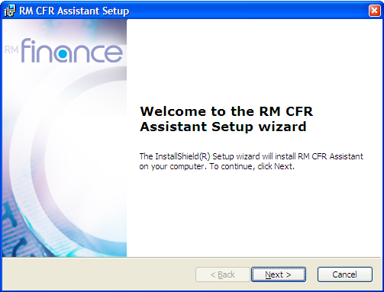
- After a few seconds, the Windows Installer window shown in Figure 1 will be shown.
Figure 1 – RM CFR Assistant Installer

- Clicking on the Next button will present you with an End User License Agreement. You must accept the terms of this agreement, and then click Next to proceed through the installation wizard.

- You should choose to install a Complete installation of the program when asked.

- After installing the CFR Assistant, you can run the software by clicking on the Start button and selecting CFR Assistant from the RM Management Solutions folder on the menu.

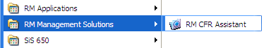
Figure 2 – Start Menu

The first time you start the CFR Assistant software you will have to create a new datafile before you can log into the software. This datafile contains all the information that you enter into the CFR Assistant. Please note that this datafile is for the CFR Assistant Software – you should not connect the stand-alone variant of the CFR Assistant to an existing Integris or RM Finance datafile.

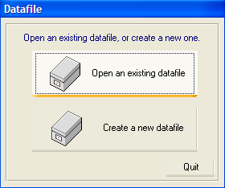
When you activate the CFR Assistant after installing it for the first time, the system displays the Datafile window.
Figure 3 – Datafile Window

To create the new datafile, click on the Create a new datafile button. You can specify the name of your datafile, and then click on the OK button to create the datafile. Datafiles are not allowed to contain certain characters or have certain names. You will be warned if you choose an invalid datafile name.

Two files will be created – one will be called datafile name.df1, and the other is datafile name.def. Both of these files make up the data for the CFR Assistant, and hence the two files should always be kept together. Whenever you move, copy or take a backup of the datafile, you must include the .def file in your movement, copy or backup process.

If you wish to have many users accessing the same datafile, you may choose to place your datafile in a shared folder on your computer, or on a server that more than one person can access. Once the datafile has been created, other users should not create a new datafile, but should instead choose the Open an existing datafile button from the window above, and choose the datafile that you have just created.

Verifying the installation

Once the installation is complete you should verify that the modules have installed correctly on your system. To perform this check:

- Open CFR after performing your upgrade/installation.
- From the Help menu, select System Information.

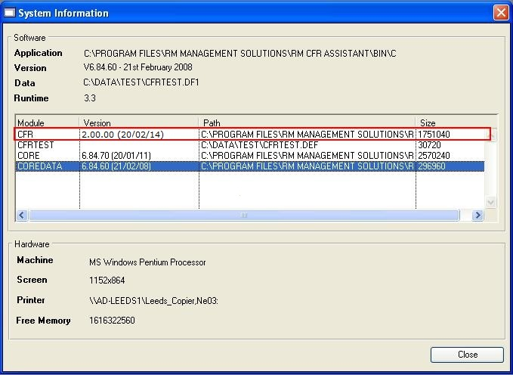

The installation has been successful if the CFR module is showing version 2.00.00 (20/02/14) as highlighted in the image above.

